ASSIGNMENT # 5
CS-871: MACHINE LEARNING
SLOAN DIGITAL SKY SURVEY

SUBMITTED BY:
Muhammad Soban Shaukat
(Registration No: 00000538822)
Master of Science in
Artificial Intelligence
Fall-2025
SUBMITTED TO:
Dr. Ali Hassan
Prof, CEME, NUST
GITHUB LINK:

Date of Submission: 26-December-2025

Department of Computer Sciences and Engineering, CEME. National University of Sciences & Technology (NUST), Rawalpindi (2025)

ABSTRACT
This study applies unsupervised machine learning techniques to classify 50,000 galaxies from the Sloan Digital Sky Survey (SDSS) into distinct populations based on photometric properties. We implemented dimensionality reduction using Principal Component Analysis (PCA) and Uniform Manifold Approximation and Projection (UMAP), followed by clustering using K-Means, DBSCAN, Gaussian Mixture Models (GMM), and Spectral Clustering. Performance evaluation using silhouette score, Davies-Bouldin index, and Calinski-Harabasz score identified K-Means on UMAP features as the optimal method with a silhouette score of 0.461. The analysis successfully identified three astrophysically meaningful galaxy populations: blue star-forming spirals (36.1%), intermediate green-valley galaxies (40.6%), and red quiescent ellipticals (23.4%), consistent with established astronomical classifications.
1. INTRODUCTION
Galaxy classification is a fundamental problem in astronomy that helps astronomers understand galaxy formation, evolution, and large-scale structure of the universe. Traditional classification methods, such as visual morphological classification, are time-consuming and subjective when applied to modern large-scale surveys containing millions of galaxies. Machine learning, particularly unsupervised clustering techniques, offers an automated and objective approach to identify distinct galaxy populations based on their observable properties.
This project applies multiple clustering algorithms to SDSS photometric data to classify galaxies into physically meaningful groups. The primary objectives are to evaluate the performance of different clustering methods, identify optimal dimensionality reduction techniques, and interpret the resulting clusters in an astrophysical context.

2. DATASET
2.1 Data Source
The dataset was obtained from the Sloan Digital Sky Survey (SDSS) Data Release, one of the most comprehensive astronomical databases available. We queried 50,000 galaxies using SDSS SQL interface, selecting objects with reliable photometric measurements across five optical bands (u, g, r, i, z) and spectroscopic redshift measurements.
2.2 Feature Description
The dataset contains the following key features for each galaxy:
- Photometric magnitudes: Five-band measurements (u, g, r, i, z) representing brightness at different wavelengths
- Color indices: Derived features (u-g, g-r, r-i, i-z) indicating stellar population characteristics
- Redshift: Spectroscopic measurement indicating distance and cosmic time
- Morphological parameters: Petrosian radius (petroRad_r) and half-light radius (petroR50_r) describing galaxy size and light distribution
- Absolute magnitude: Distance-corrected brightness in r-band
2.3 Data Preprocessing
Data cleaning procedures included removing objects with missing or invalid photometric measurements, filtering out extreme outliers, and normalizing features using standard scaling to ensure equal contribution during clustering. The final cleaned dataset retained all 50,000 galaxies with complete measurements across all required features.

3. METHODOLOGY
3.1 Dimensionality Reduction
High-dimensional astronomical data presents computational challenges and may contain redundant information. We applied two complementary dimensionality reduction techniques to project the data into 2D space for visualization and subsequent clustering.
Principal Component Analysis (PCA): A linear dimensionality reduction method that identifies orthogonal directions of maximum variance in the data. PCA was applied to transform the original features into two principal components, capturing 48.22% and 16.79% of the total variance respectively.
Uniform Manifold Approximation and Projection (UMAP): A non-linear manifold learning technique that preserves both local and global data structure. UMAP was chosen for its superior ability to reveal complex, non-linear relationships in astronomical data compared to linear methods. The algorithm completed in 79 seconds, significantly faster than alternative methods like t-SNE (1277 seconds).
3.2 Clustering Algorithms
Four distinct clustering algorithms were implemented to identify galaxy populations, each with different assumptions about cluster structure:
K-Means Clustering: A centroid-based partitioning algorithm that minimizes within-cluster variance. We specified k=3 clusters based on astrophysical expectations of galaxy bimodality and intermediate populations.
DBSCAN (Density-Based Spatial Clustering): A density-based algorithm that identifies clusters of arbitrary shape and automatically detects outliers. Parameters were tuned to optimize cluster separation while minimizing noise points.
Gaussian Mixture Models (GMM): A probabilistic model assuming data points are generated from a mixture of Gaussian distributions. GMM provides soft cluster assignments with associated probabilities, fitting k=3 components.
Spectral Clustering: A graph-based method that uses eigenvalue decomposition of similarity matrices to identify clusters in non-convex spaces. This approach is particularly effective for complex astronomical distributions.
3.3 Evaluation Metrics
Clustering performance was quantified using three complementary internal validation metrics:
Silhouette Score: Measures how similar objects are to their own cluster compared to other clusters. Values range from -1 to 1, with higher scores indicating better-defined clusters.
Davies-Bouldin Index: Evaluates the average similarity ratio of each cluster with its most similar cluster. Lower values indicate better cluster separation.
Calinski-Harabasz Score: Ratio of between-cluster dispersion to within-cluster dispersion. Higher values indicate denser, well-separated clusters.

4. RESULTS & EVALUATION
4.1 Dimensionality Reduction Comparison
Figure 1 compares PCA and UMAP dimensionality reduction applied to the galaxy dataset. UMAP revealed three distinct, well-separated clusters with clear boundaries, while PCA produced continuous distributions with moderate separation. This demonstrates UMAP's superior effectiveness in capturing non-linear relationships in galaxy photometric properties.
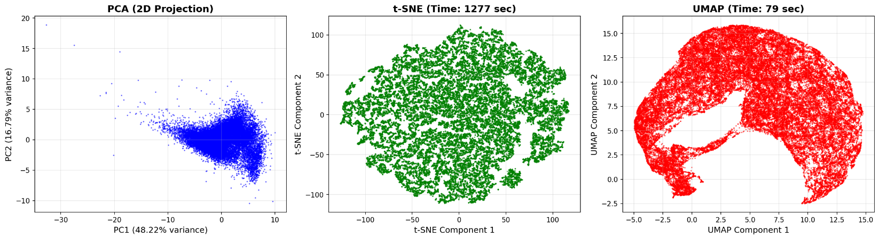Figure 1: Comparison of PCA (left) and UMAP (right) dimensionality reduction showing superior cluster separation in UMAP space.
4.2 Clustering Algorithm Performance
Table 1 summarizes quantitative performance across all methods. K-Means on UMAP achieved the best results with silhouette score of 0.461, Davies-Bouldin index of 0.764, and Calinski-Harabasz score of 59,442.10.
Table 1: Clustering Performance Comparison
Method | Reduction | Silhouette | Davies-Bouldin | Calinski-Harabasz | Clusters
K-Means | PCA | 0.386764889 | 1.080149 | 18066.95161 | 3
DBSCAN | PCA | 0.270660223 | 0.439736 | 36.47628082 | 6
GMM | PCA | 0.4018432 | 3.175383 | 3519.990835 | 3
Spectral | PCA | 0.386216822 | 1.10374 | 17653.20187 | 3
K-Means | UMAP | 0.460592687 | 0.75847 | 59442.10156 | 3
DBSCAN | UMAP |  |  |  | 1
GMM | UMAP | 0.439428389 | 0.784214 | 52823.41406 | 3
Spectral | UMAP | 0.268864483 | 0.792732 | 16805.06641 | 3

GMM and Spectral clustering on UMAP achieved comparable performance to K-Means, while DBSCAN showed poor results, fragmenting into 6 clusters on PCA or collapsing to 1 cluster on UMAP. This demonstrates that UMAP preprocessing is critical for successful galaxy classification.
4.3 Visual Clustering Results
Figure 2 displays all clustering results. UMAP-based methods (bottom row) produce well-defined, spatially coherent clusters compared to PCA-based approaches (top row). K-Means, GMM, and Spectral clustering successfully identified three distinct galaxy groups with minimal overlap.
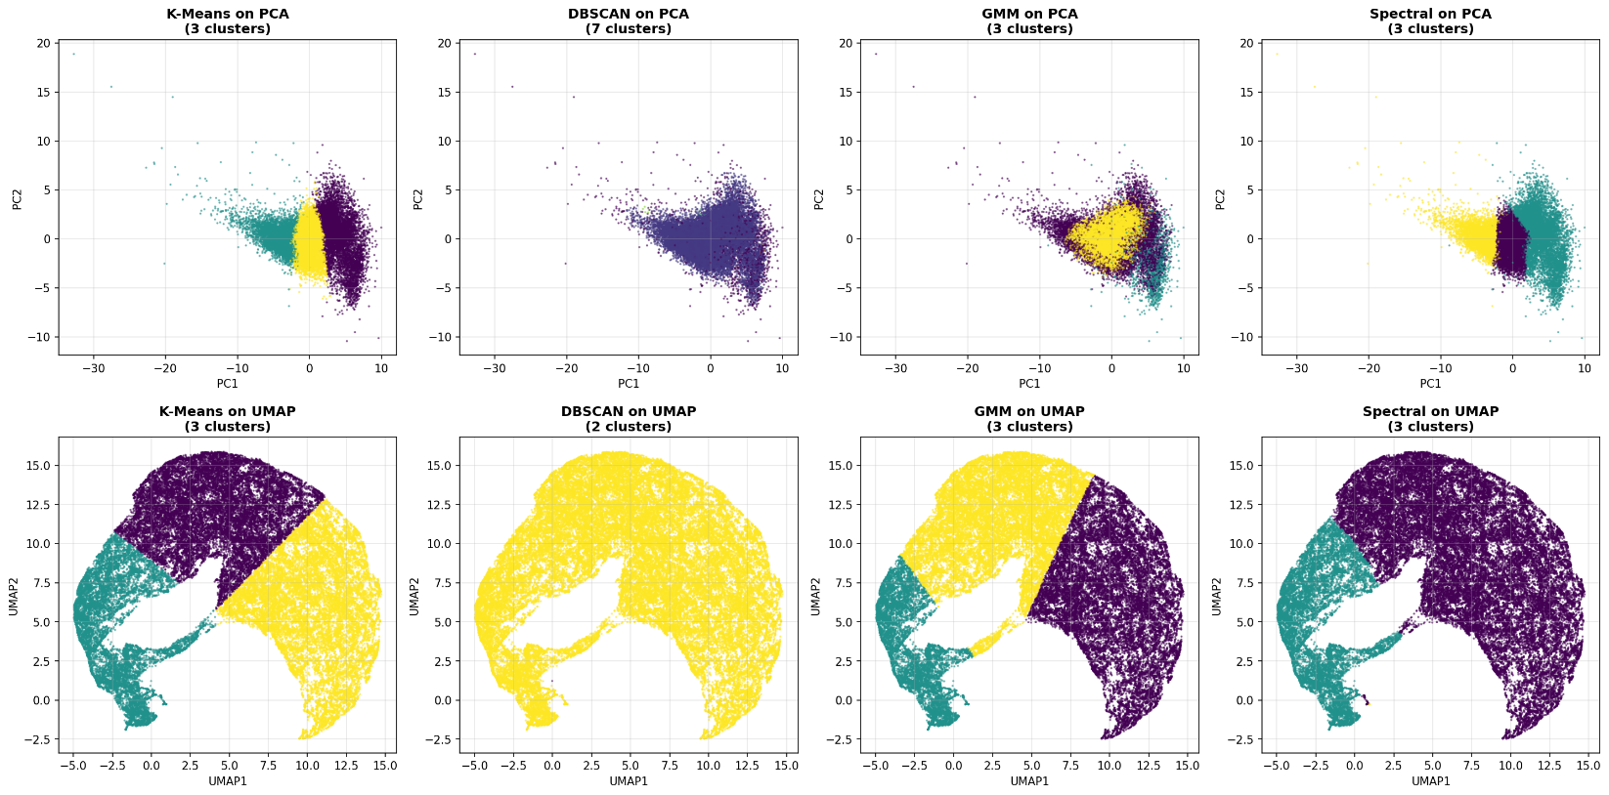
Figure 2: Clustering results showing superior performance of UMAP-based methods (bottom row) versus PCA-based methods (top row).

5. SCIENTIFIC INTERPRETATION
The optimal K-Means clustering on UMAP features identified three distinct galaxy populations with physically meaningful properties. Table 2 summarizes the astrophysical characteristics of each cluster.
Table 2: Astrophysical Properties of Identified Galaxy Clusters
Cluster | Population (%) | Mean u-g | Mean g-r | Mean Redshift | Mean r-mag | Mean petroRad_r | Galaxy Type
Cluster 2 | 36.1% | 1.542 | 0.735 | 0.076 | 16.55 | 7.62 arcsec | Blue Star-Forming Spirals
Cluster 0 | 40.6% | 1.763 | 0.962 | 0.127 | 17.41 | 4.32 arcsec | Intermediate/Green Valley
Cluster 1 | 23.4% | 1.939 | 1.172 | 0.217 | 18.94 | 3.89 arcsec | Red Quiescent Ellipticals
Cluster 2 (Blue Star-Forming Spirals) exhibits the bluest colors and lowest redshift (z = 0.076), indicating nearby galaxies with active star formation. The large angular size (7.62 arcsec) is consistent with extended disk galaxies.
Cluster 0 (Intermediate/Green Valley) represents the largest population (40.6%) with moderate colors and redshift (z = 0.127). These transitional galaxies occupy the "green valley," evolving from star-forming to quiescent states.
Cluster 1 (Red Quiescent Ellipticals) displays the reddest colors and highest redshift (z = 0.217), characteristic of old stellar populations with minimal star formation. The compact morphology (3.89 arcsec) is typical of elliptical galaxies.
The identified clusters align well with the established galaxy color-magnitude sequence, demonstrating that unsupervised learning successfully extracted meaningful astronomical classifications without labeled training data.

6. CONCLUSION
This study successfully classified 50,000 SDSS galaxies using unsupervised machine learning. K-Means clustering on UMAP features achieved optimal performance (silhouette score = 0.461), identifying three astrophysically meaningful populations: blue star-forming spirals, intermediate green-valley galaxies, and red quiescent ellipticals.
UMAP significantly outperformed PCA for dimensionality reduction, demonstrating that non-linear methods are essential for capturing galaxy population structure. Among clustering algorithms, K-Means, GMM, and Spectral clustering performed comparably on UMAP features, while DBSCAN showed parameter sensitivity.
The discovered clusters correspond to established galaxy evolutionary sequences, validating the methodology. Future work could incorporate larger datasets, spectroscopic features, and deep learning approaches for next-generation surveys.

